Sprint 2 – Accuracy Design Document

April 11, 2022

Table of Contents
1. Executive Summary 3
1.1 Project Overview 3
1.2 Purpose and Scope of this Specification 3
2. Product/Service Description 3
2.1 Product Context 3
2.2 User Characteristics 3
2.3 Assumptions 3
2.4 Constraints 3
2.5 Dependencies 4
3. Requirements 4
3.1 Functional Requirements 5
3.2 Security 5
3.2.1 Protection 5
3.2.2 Authorization and Authentication 6
3.3 Portabilty 6
4. Requirements Confirmation/Stakeholder sign-off 6
5. System Design 6
5.1 Algorithm 6
5.2 System Flow 6
5.3 Software 6
5.4 Hardware 6
5.5 Test Plan 7
5.6 Task List/Gantt Chart 7
5.7 Staffing Plan 7

Executive Summary

Project Overview
This part of the project will successfully run the figure eight course 5 times. The robot must follow the path laid out on the floor and will return to its original spot.

Purpose and Scope of this Specification
The purpose of this test and part 2 of it is to prove and see how well the robot can go. The end goal is win but also improve along the way.
In scope:
The robot must follow the code given and determine where it goes and ends up at
Out scope:
The actual surface of the robot must control how it moves and how it lands. The robot has to be composed throughout the sprint.

Product/Service Description
General factors of this robot are that it has a good interface and can be managed by the block code made on the Sphero app.

Product Context
This product is going after 1st place and is continuing to make great progress. Once again, passing its potential compared to the first test. The robot is dependent on the app but executes the block code well.

User Characteristics
The team using this robot are:
- Alejandro Suarez
- Ryan Huitzil

Assumptions
Some things that could affect the testing is a malfunction of the robot or an off-balance block code. The robot must be charged to ready to test. Other have had robot malfunctions and hopefully, no switch must be made.

Constraints
Items that could constrain the design options are,
- Bugs with the app
- Possible trouble with saving block code
- Classroom being used for testing by others.

Dependencies
This time, the robot will only need to follow it’s given directions and be able to manage using any recent update bug fix on the app.

Requirements
Requirements that are needed for this sprint to work and go through are:
- going around the eight figure 5 times, being able to stay in track,
- must speak at the end and say, “I am the Winner”.
- All these requirements are top priority in order to succeed and be ahead of its competitors.
- A block code should be well established as well.

Functional Requirements
Req# | Requirement | Comments | Priority | Date Rvwd | SME Reviewed / Approved
ACCUR_01 | Robot must run the path 5 times | The robot must run and come back 5 times | 1 | 4/11/22 | Approved
ACCUR_02 | Robot must start and finish in the square provided | Must be done to be considered finished | 1 | 4/11/22 | Reviewed
ACCUR_03 | Robot must say “I am the Winner” | Must announce that it won | 1 | 4/11/22 | Approved
ACCUR_04 | Flash Multi-Colored lights for 5 seconds | When reaching the end, it must flash the colors to signal the test is over | 1 | 4/11/22 | Approved

Security

Protection
Some ways the code and robot don’t get hacked or bugged:
- encryption
- checking activity logging
- Not sharing password

Requirements Confirmation/Stakeholder sign-off
Meeting Date | Attendees (name and role) | Comments
04/07/22 | Ryan H & Alejandro S | Setting up plan
04/11/22 | Ryan H & Alejandro S | Robot tests should be done

System Design
This section will provide all details concerning the technical design, staffing, coding, and testing the system

Algorithm
Start
Roll 18 Degrees at 50 speed for 1s
Roll 61 Degrees at 50 speed for 1s
Roll 100 Degrees at 50 speed for 1s
Roll 130 degrees at 50 speed for 1s
Roll 160 degrees at 50 speed for 1s
Roll 205 degrees at 50 speed for 1s
Roll 235 degrees at 50 speed for 1s
Roll 270 degrees at 50 speed for 1s
Roll 315 degrees at 50 speed for 1s
Roll 345 degrees at 50 speed for 1s
Roll 250 degrees at 50 speed for 1s
Roll 237 degrees at 50 speed for 1s
Roll 185 degrees at 50 speed for 1s
Roll 150 degrees at 50 speed for 1s
Roll 130 degrees at 50 speed for 1s
Continue to reduce degrees by 40 then decrease to 13
Repeat steps 5 times
Speak “I am the winner”
Fade from blue to red for 5 seconds
End program

System Flow
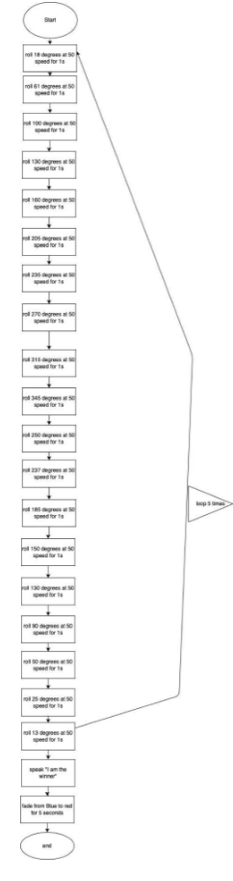

Software
Software used in this part Is only the block code and Sphero Edu app.

Hardware
The Sphero Edu robot was used

Test Plan

Reason for Test Case | Test Date | Expected Output | Observed Output | Staff Name | Pass/Fail
First curve | 4/11 | To make a curved movement | It went straight | Alejandro | Fail
First curve | 4//11 | The robot should make its first steps to make a curve | It made a slight curve but not enough | Alejandro | Fail
Half of a circle | 4/11 | The robot should be able to go half of one circle | Robot was able to pull it off | Alejandro | Pass
Complete a circle | 4/11 | Robot should do a complete circle | Robot almost completed it but fell short | Alejandro | Fail
Try two for complete circle | 4/11 | Robot needs to complete a circle | It did and turned right to start the next circle | Alejandro | Pass
Robot needs to go around the second circle to make an eight | 4/11 | Robot must continue its run | Robot came short and stopped | Alejandro | Fail
Try two to make robot complete the eight figure | 4/11 | Robot has to complete the run | Robot once again didn’t make it | Alejandro | Fail
Try three to make robot complete the eight figure | 4/11 | Robot to improve from last run | Robot passed its previous record but came short | Alejandro | Fail
Robot must reach starting point | 4/11 | Robot needs to finish the course | The robot almost made it | Alejandro | Fail
Try two of reaching end point | 4/11 | Robot must be back at its starting point | Robot makes it | Alejandro | Pass
Robot must speak and flashlights | 4/11 | Robot must speak and show colors | Robot spoke and showed colors | Alejandro | Pass

Task List/Gantt Chart
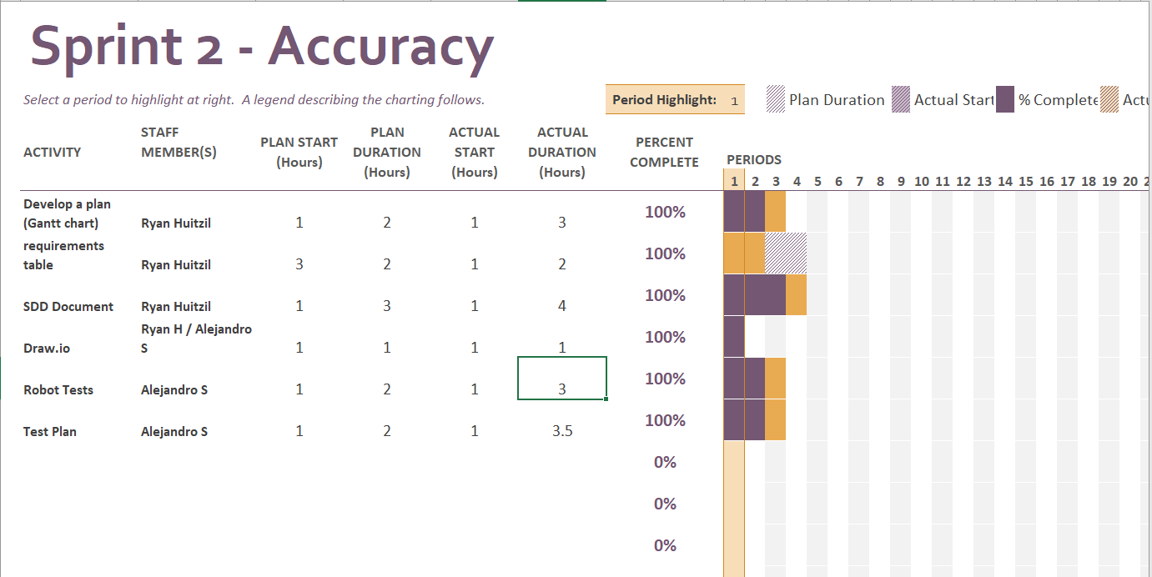

Staffing Plan

Name | Role | Responsibility | Reports To
Ryan H | Leader | SDD Document / Gantt Chart | SDD Document
Alejandro S | Block Coder | Robot Code / Algorithm | Ryan

